Wipro interview questions

1.can we discussed  about docker?how good about docker

We working on deployment and testing use and production everything in kubernetes so

I have both exp docker and Kubernetes

**Docker is lightweight and fast**. It provides a viable, cost-effective alternative to hypervisor-based virtual machines, so you can use more of your server

<https://www.zdnet.com/article/what-is-docker-and-why-is-it-so-darn-popular/>

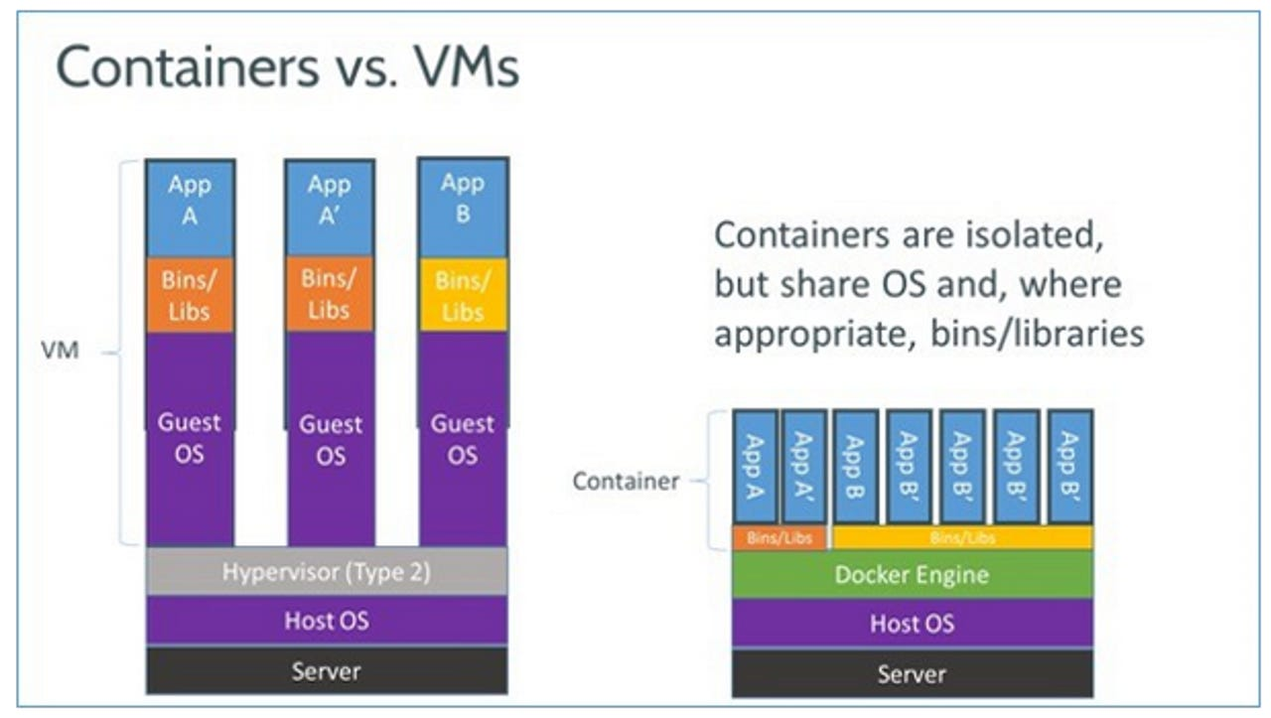

2.wt kind of Kubernetes platform ur using?

I have experience with azure aks

As well as AWS eks and also experience on premises experience as well

Kubernetes (sometimes shortened to K8s with the 8 standing for the number of letters between the “K” and the “s”) is an open source system to deploy, scale, and manage containerized applications anywhere.

3.i have application which is deploying in eks or aks for automated way  so can you please explain wt are steps we need follow? From scratch

<https://docs.aws.amazon.com/eks/latest/userguide/sample-deployment.html>

<https://cto.ai/blog/intro-to-kubernetes-workflow-automation-with-aws-eks-gcp-gke-azure-aks/>

<https://learn.microsoft.com/en-us/azure/aks/learn/quick-kubernetes-deploy-portal?tabs=azure-cli>

Now I have eks set-up but nothing is running on there

Assuming that we have already have the eks cluster it is kubernetes cluster and also Jenkins and azure devops also part of the integration

1step will be basic pipeline we want to communicate with end to end based upon the branch actually

I will assume we have branch UAT production

Example I will take the Java spring boot application which need to part of the solution

1 st Check the code static code analysis doing with sonar cube

So sonar code is good solution for static code analysis

4.im not taking about sonar cube here my point how to deploy k8s environment?

<https://www.techtarget.com/searchitoperations/tutorial/How-to-set-and-manage-environment-variables-in-Kubernetes#:~:text=The%20first%20option%20is%20to,a%20deployment%20named%20example%2Ddeployment>.

I have docker images ready just deploy into the kubernetes cluster?

We can do it three different ways actually

1.way

.Easy way is update manifest file images and perform kubectl apply command

Or else

2.way

We can also use helm chart

It is complete application

We can update the value file and we have use help install command and to the confirm the thing

3.way

Constamized

It is used can be

If don't want use help chart and if u want do it into simple way use the constamized to deploy the k8s

4.wt is diff between rolling update and rubric deployment?

<https://octopus.com/docs/deployments/patterns/rolling-deployments>

<https://docs.aws.amazon.com/whitepapers/latest/overview-deployment-options/bluegreen-deployments.html>

<https://docs.aws.amazon.com/whitepapers/latest/overview-deployment-options/rolling-deployments.htm>

Rolling update is also called as pod update

Advantage

We can save the cost

But revert can be issued

If it canary based deployment like

We can create completely infrastructure we can send traffic pritially in case of canary

We can do the switch traffic to green deployment

Something wrong we can switch back to environment  it is recommended method basically give the downtime

5.What is diff between kubectl vs helm?

<https://medium.com/@RedBaronDr1/helm-vs-kubectl-5aaf2dba7d71>

kubectl is a command-line tool for interacting with a Kubernetes cluster. Helm is used to install and upgrade Determined on Kubernetes. This section covers some of the useful kubectl and helm commands when running Determined on Kubernetes.

Kubectl is Kubernetes management platform that means binary to manage the kubernetes

Helm chart is package manager

6.helm chart is package manager so the deployment happening by using helm?

The objective of Helm as package manager is to make an easy and automated management (install, update, or uninstall) of packages for Kubernetes applications, and deploy them with just a few commands.

<https://www.freecodecamp.org/news/helm-charts-tutorial-the-kubernetes-package-manager-explained/>

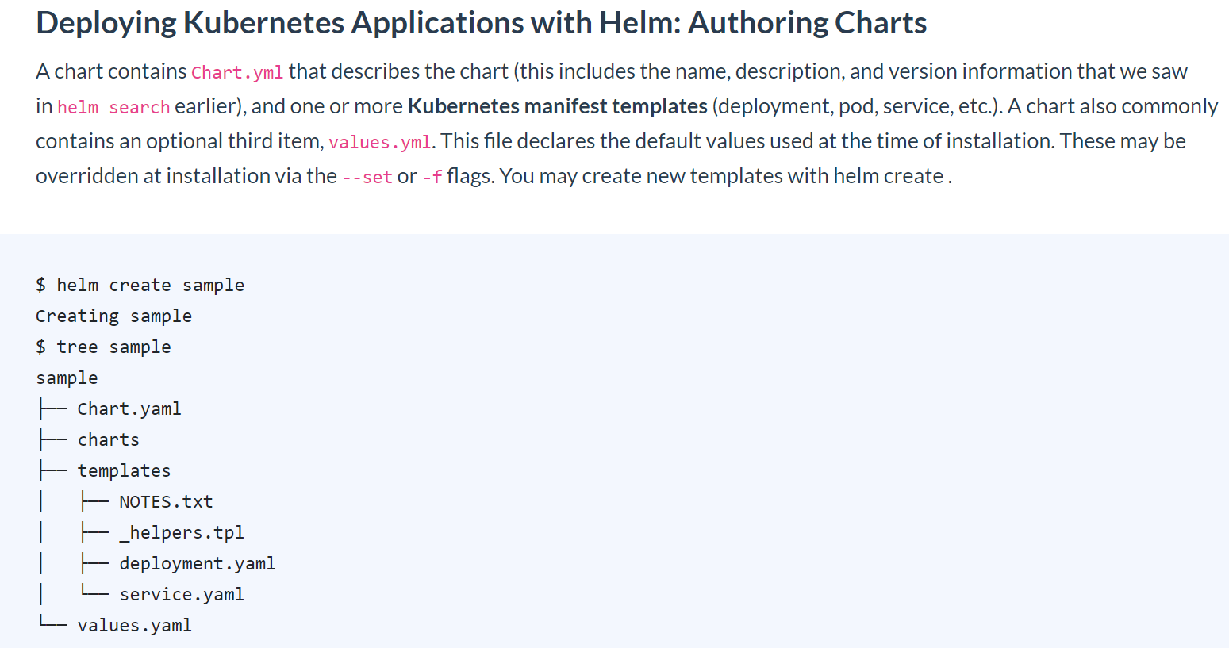

In that case I can use helm + kubectl?

Ans:

No we can actually use the helm install command and provide the name and u can provide costom value actually and using costom value roll out the changes

So kubectl not required

Helm install required

7.In the same case we can do kubectl right so we should go for helm?

kubectl is a command-line tool for interacting with a Kubernetes cluster. Helm is used to install and upgrade Determined on Kubernetes. This section covers some of the useful kubectl and helm commands when running Determined on Kubernetes.

<https://medium.com/@RedBaronDr1/helm-vs-kubectl-5aaf2dba7d71>

So imagine we have complex application,we want deploy like 10 diff thing actually

Like 10 deployment,complex application,we want use the different data base like MySQL and postgress so this kind of complex application we can use the helm chart make it easier

If it is simple application and like 2or 3 deployment we can go kubectl

8. Wt is rate is terraform?

Ans:

3 to 4 in terraform

9.wt are activities u did in terraform?

I have created infra AWS and azure and created modules

In good experience terraform function like

Count as well as elements

Even I used the terraform provision and providers

10.u said the count so wt are all scenarios we can go head count?wt other scenario go for each ?

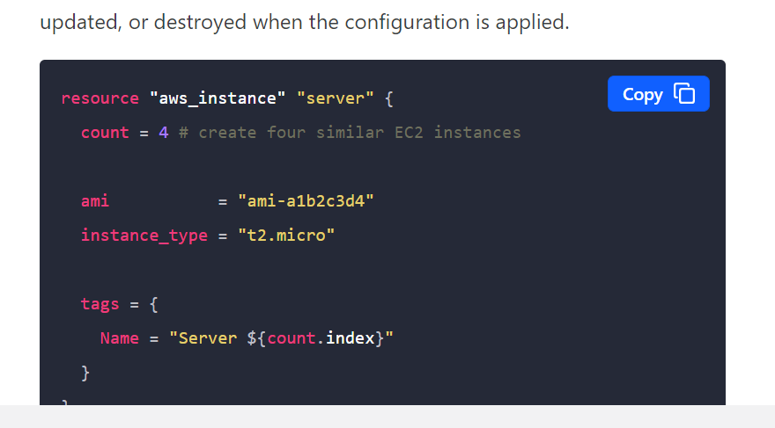

Count is good solution to create the multible resources

For example if want to create 5 virtual machines then actually use the count

It will take least basically to take the count

Imagine in the same case we have security group in aws

We need to create 10 security group if u want create

Count is not a good solution,it is not create the resource

But it is create object inside the resource

In that case for each is good solution using the dynamic block

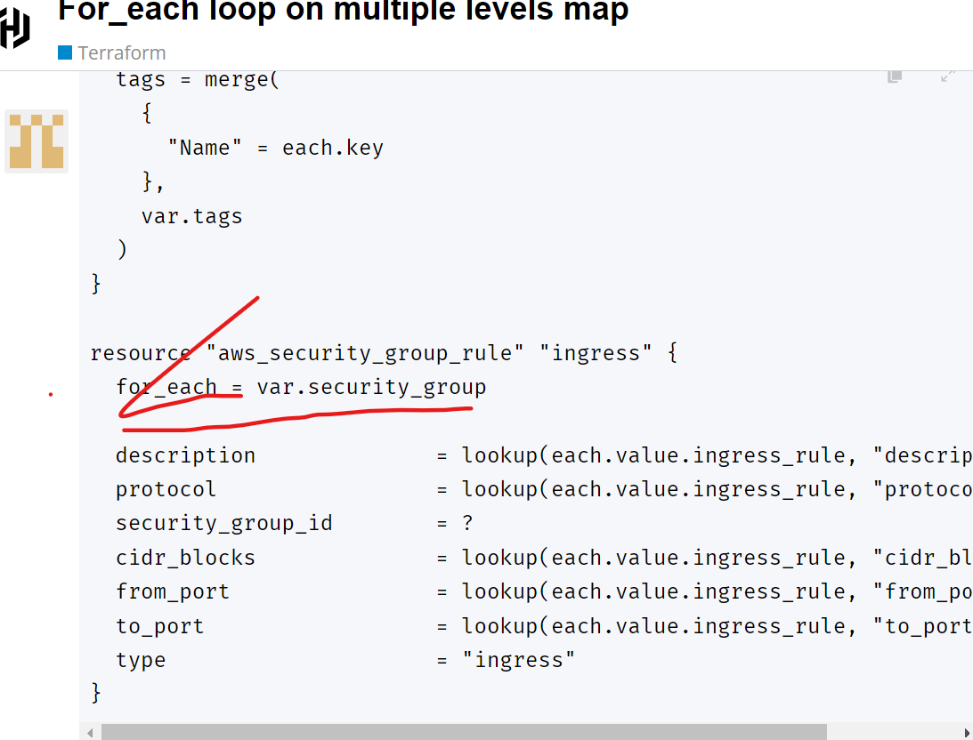

<https://discuss.hashicorp.com/t/for-each-loop-on-multiple-levels-map/17706>

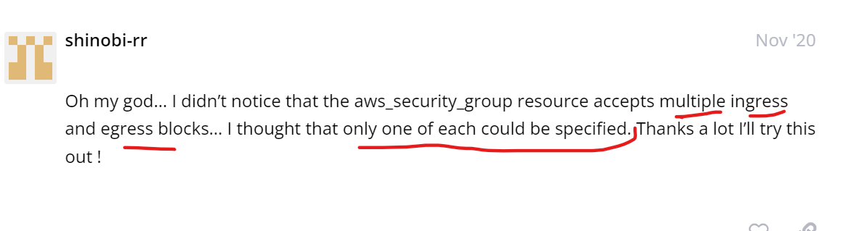

================

We want create 10 sg in aws

We have create 20rules actually so we can't use count here

Bcz it count use resource level

So for each is good solution

12.have us used in dynamic in terraform?

U r asking about dynamic blocking

Mostly used in the security group and I am policy

Im not wrking dynamic

The Dynamic Block in Terraform is one of the most useful options for making your code dynamic. Previously, we could use dynamic conditions like 'for_each' and 'if' conditions at the resource block leve

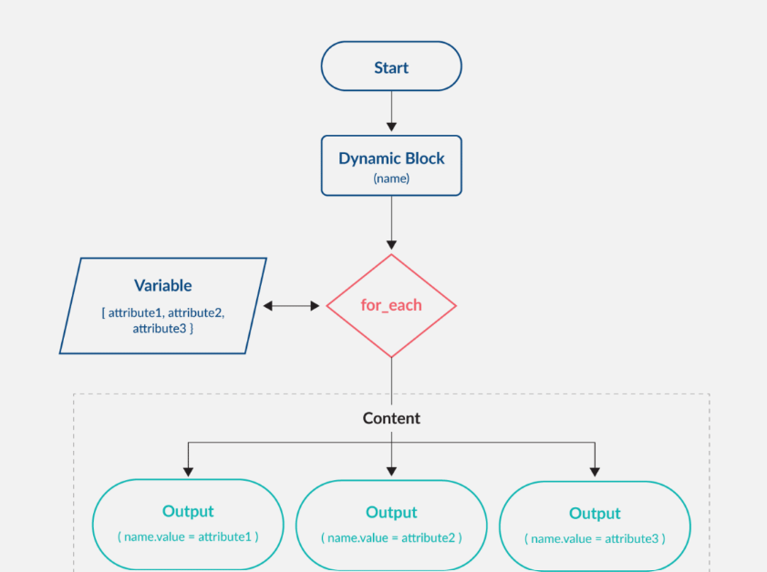

<https://www.cloudbolt.io/terraform-best-practices/terraform-dynamic-blocks/>

13.i have aks cluster and increased VNET some time back now I have to map the aks cluster as part of terraform?how can I do that

Data sources in Terraform are used to get information about resources external to Terraform, and use them to set up your Terraform resources. For example, a list of IP addresses a cloud provider exposes.

<https://spacelift.io/blog/terraform-data-sources-how-they-are-utilised>

Since vnet already created which is not to part of terraform we need use data source actually and to get the details of the vnet and so we can actually deploy aks on that one

If any information not available in terraform state

So we can use the data source and to get that

14.i have vnet as part of the terraform and it is different module and it is map to aks creation and so still we need go for data source?

We can put values actually,output.tf we can add the cluster

15.wt is diff between variable file and tf.var file?

Variables.tf is for the declaration of variables, name, type, description, default values and additional meta data. *. tfvars is for giving the actual variable values during execution. It allows you to customize the specific execution

Variable file is not mandatory actually,it is declared variable,

Make sure that available at one centre location that y we create variable.tf

It is use the define the variable

If don't define the variable key ward

If we can terraform plan and apply so we get the error bcz variable declaration is not declare

Declared the variable using variable file

Default value for that we can use tf.war

16.i have fetch the from secret,any one open the state file,can restrict that I don't want secret data in statefile ?how to do it?

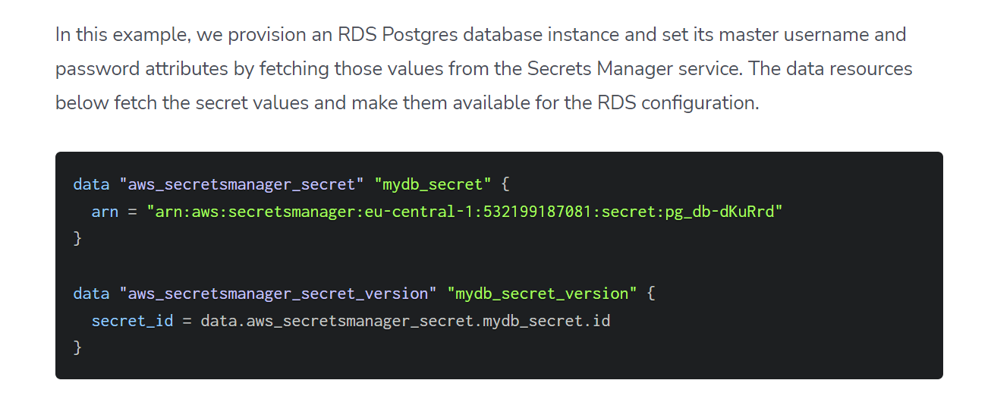

That is design by terraform

We are put statefile into the git repository

If u generate the pwd the best way put into the azure key valut or AWS secret manager access them

17.coming back to scripting do have experience in powe shell?

I used bash scriptinf and lit bit of power shell

But I think fundamental syntax difference

I have more experience in bash script

18.East us & West us

Resources group available in json file

I need fetch the data East us

My intention specific region I need fetch wt r resources deployment can please write shell scripting?

Everything have json file so I don't have time read json so just pass input in shell scripting? So central us this are the resources

[https://docs.aws.amazon.com/cli/latest/reference/resourcegroupstaggingapi/get-resources.html#](https://docs.aws.amazon.com/cli/latest/reference/resourcegroupstaggingapi/get-resources.html)

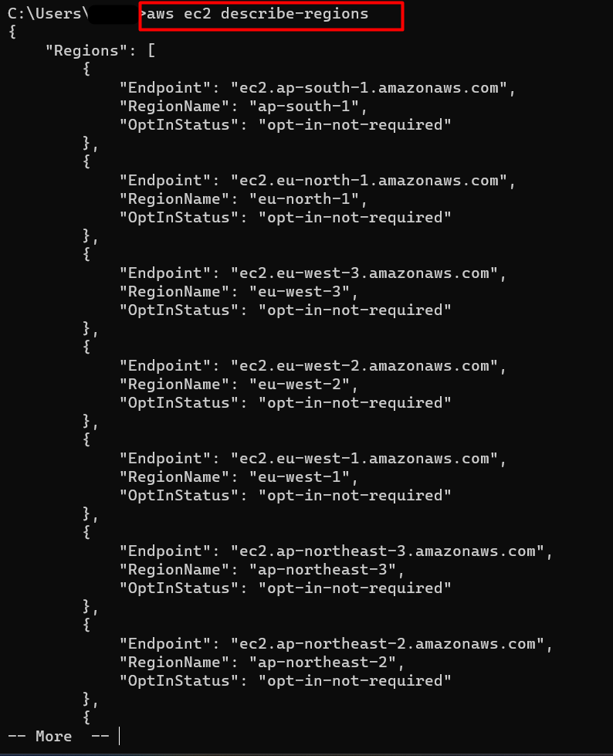

<https://linuxhint.com/describe-regions-command-aws-cli-2/>

So west us this are the resources do the shell scripting

For example text.sh to pass parameters

Ans:I think

Basically used in jq

It is good function actually

It is using good output

We need to find list and objects so we can jq to get the information

19. from jq how r u display the data

<https://gist.github.com/hummus/8592113>

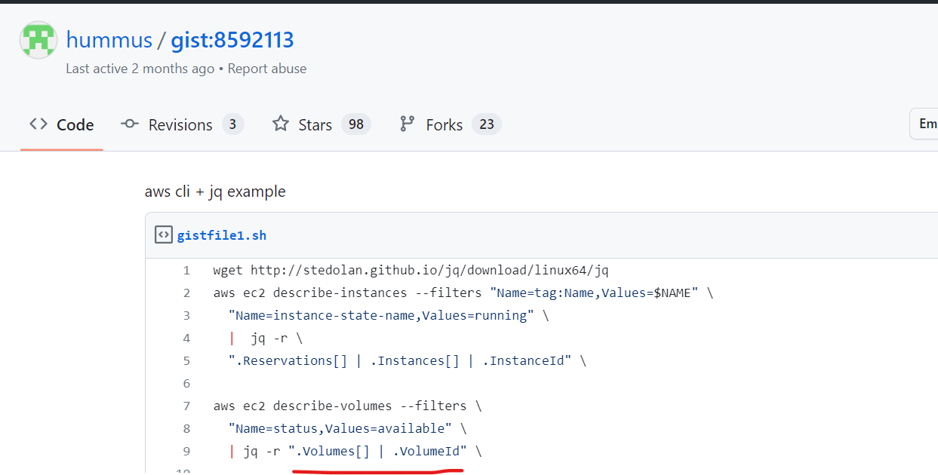

I will take AWS example

AWS ec2 describe | jq

AWS ec2 describe vpc doller1 get inf

I have multi region

Doller @ accress script .sh fetch mutle inputs

What is the use of jq?

jq , a command-line JSON processing tool, is a good solution for dealing with machine-readable data formats and is especially useful in shell scripts. Using jq can aid you when you need to manipulate data. For example, if you run a curl call to a JSON API, jq can extract specific information from the server's response

20.how u r worked on git lab?

GitLab is an Open Source code repository and collaborative software development platform for large DevOps and DevSecOps projects. GitLab is free for individuals. GitLab offers a location for online code storage and capabilities for issue tracking and CI/CD.

More on Jenkins azure devops

Few projects deployed in git lab

Secure file , variable by using git

Since I have managed azure devops & Jenkins

21. R u work experience in the creating yaml file?

Ansible

Azure devops pipeline

https://azuredevopslabs.com/labs/vstsextend/ansible/

22.in azure devops did u wrk basing editor?

New environment to yaml pipeline

From lagacy project

We r using classic file

Everything will be yaml file

23.wt are advantage of yaml?

The YAML specification has minimal leeway for flexibility, which increases its robustness. It has a simple and clean syntax. YAML is easy to learn and simple to read. It can express a wide variety of different native data structures and allows for custom extensions.

Integrated along with repo

It is challange

It is simple make the changes in pipeline

It is easily identify adding the stages

Updated easy in yaml

It is good readable format actually

Is not same case in the gui

24.any other advantages of yaml?

I can see

1.reading easy

2.easy to update

3.it is identify easily in yaml,by default it is support git hub action and azure devops

This are thing I feel like advantage

25.how u worked on multi staging pipeline?

<https://learn.microsoft.com/en-us/azure/devops/pipelines/process/create-multistage-pipeline?view=azure-devops>

I can see it is multi branch pipeline

Based upon branch using when condition

<https://medium.com/@sangeetv09/how-to-create-simple-multistage-jenkins-pipeline-job-7a5d6113e429#:~:text=I've%20created%20a%20Pipeline,must%20save%20and%20move%20on>.

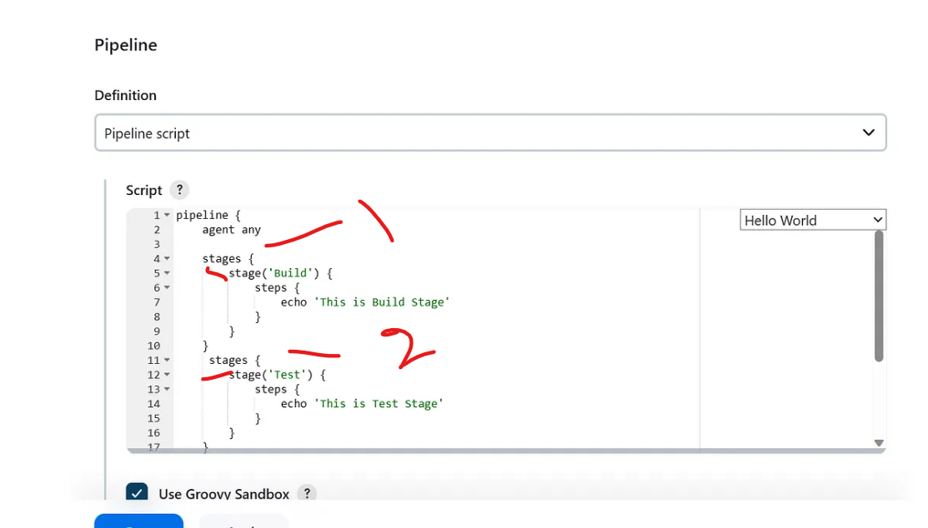

26.what do mean by multi branch pipeline?

<https://devopscube.com/jenkins-multibranch-pipeline-tutorial/>

The Multibranch Pipeline project type enables you to implement different Jenkinsfiles for different branches of the same project. In a Multibranch Pipeline project, Jenkins automatically discovers, manages and executes Pipelines for branches which contain a Jenkinsfile in source control

It is simple pipeline.

Depend upon the pull request like

Devlopment

Uat

Production

In the same we will push it and depending upon the branch automatically that particular variable used and deployed

Of course everything has multiple stages

In single pipeline and multiple environment

Like devlopment and uat and production

27.Wt kind of application setup by using Jenkins?

So most of Java and spring boot application exp

It is jar and war like artifact,i did the cicd pipeline

We have separate infrastructure like terraform pipeline

We have different applications

And we have different cicd pipeline

28.how u worked on dot.net based application by using cicd?

I know the ms build for the .net application, unforntly i don't have opportunity wrk on .net application

But it is build tool and ms build,i think pipeline logic and remain same

29.wt is over all experience?

7rel

4 exp relevant exp devops

30.how u worked on octopus deploy?

Mostly i worked on ansible

Octopus it is deployment tool

I didn't get opportunity wrk on that but I happy Learn